BridgeSummaryReport
State Name(1):28-Mississippi StructureNumber(8):21000900240494A InspectionDate(90):July 2016
ConditionRatingand Evaluation
Identificatiorand Location
BridgeRailings(36A):0-Does notmeetcurrentlyacceptablestanda..
HighwayAgencyDistrict(2):06-District6
CountyName(3):047-HarrisonCounty
Transitions(36B):0-Does notmeetcurrentlyacceptablestandards
Place Code(4):6220
ApproachGuardrail(36C):1-Meetscurrentlyacceptablestandards
Features Intersected(6A):BILOXI BAY
BridgeGuardrailEnds (36D):1-Meetscurrentlyacceptablestandard... Deck ConditionRating(58):8-Very GoodCondition SuperstructureConditionRating(59):7-GoodCondition
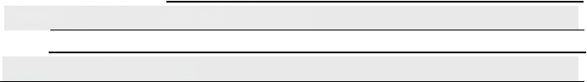
SubstructureConditionRating(60):7-GoodCondition
Facility Carried By Structure(7):US 90
Location(9):HARRISON/JACKSON CL MilePoint,miles(11):0
Latitude,decimal(16):30.41109 Channeland ChannelProtectionConditionRating(61):7-Channelre...
CulvertsConditionRating(62):N-Nota culvert
Longitudedecimal(17):-88.84106
MaintenanceResponsibility(21):1-State HighwayAgency
StructuralEvaluationAppraisal(67):7-BetterThan Present Minimu..
Deck GeometryAppraisal(68):9-Superiorto Present DesirableCrit..
Owner(22):1-State HighwayAgency
UnderclearanceAppraisalVerticaland Horizonta(69):N-N/A WaterwayAdequacyAppraisal(71):9-Superiorto Present Desirable.. ApproachAlignmentAppraisal(72):7-BetterThan Present Minimumc... Scour CriticalBridges Code(113):8-Foundationsstable;Scour abo.. BridgeCondition(CAT10):G-Good
Year Built(27):2008

HistoricalSignificanceCode(37):5-NotNationalRegistereligible
Neighboringtate Code(98A):
Neighboringtate Percent Responsibility(98B):
BorderBridgeStructureNumber(99):
Load Ratingand Posting
Parallel StructureDesignationCode(101):L-Leftof set in opposited..
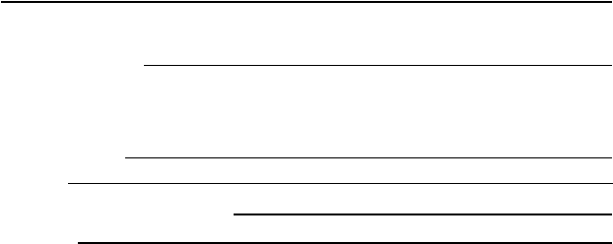
DesignLoad Descriptor(31):5-MS 18/HS 20 StructureOperationabtatus Code(41):A-Open
Year Reconstructed(106):0
StructureType and Materials
MainSpan Material(43A):6-Prestressed ConcreteContinuous MainSpan Design(43B):2-Stringer/MulHbeamorGirder
OperatingRating,US tons(64):60.6
OperatingRating MethodCode(63):1-Load Factor(LF)
ApproachSpans Material(44A):6-Prestressed ConcreteContinuous
InventoryRating Methodcode(65):1-Load Factor(LF) InventoryRating,US tons(66):36.4
ApproachSpans Design(44B):2-Stringer/Multbeamor Girder
Numberof Spans in MainUnit(45):1
BridgePosting Code(70):5-Equal toorabovelegalloads Trafficand RoadwayData
Numberof ApproachSpans (46):70
Deck StructureType Code(107):1-ConcreteCast-in-Place
Record Type(5A):1-On Structure
Route SigningPrefix Code(5B):2-U.S.numberedhighway
WearingSurface Type Code(108A):0-None MembraneType Code(108B):0-None
DesignatedLevel of Service Code(5C):1-Mainline Route Number(5D):00090
Deck ProtectionCode(108C):0-None
Dimensionsand Clearances
DirectionaS uffixCode(5E):0-NotApplicable
Base HighwayNetwork(12):1-On Base Network
InventoryRoute-MinimumVerticalClearance,ft.(10):"9999"
ApproachRoadway Width,ft.(32):57.1
Bypass orDetourLength,miles(19):1.2

BridgeMedianCode(33 ):3-Closed MedianNon-MountableBarriers Toll Status(20):3-On Free Road
Skew Angle,degrees(34):0 FunctionalClass OfInventoryRoute(26):14-Urban OtherPrincipal. StructureFlared(35):0-Noflare Lanes On the Structure(28A):3 NavigationControlCode(38 ):1-PermitRequired Lanes Underthe Structure(28B):0

NavigationVerticalClearance,ft.(39):95.8 AverageDaily Traffic(29):13,000
NavigationHorizontallearance,ft.(40):149.9 Year of AverageDaily Traffic(30):2014
InventoryRoute TotalHorizontallearance,ft.(47):57.1 Type of Service on BridgeCode(42A):1-Highway
Lengthof MaximumSpan,ft.(48):250 Type Of Service UnderBridgeCode(42B):5-Waterway
StructureLength,ft.(49):8765.7 STRAHNET HighwayDesignation(100):0-NotSTRAHNET
Directionof Traffic Code(102):1-1-way traffic
LeftCurb/Sidewalk Width,ft.(50A):0
RightCurb/SidewalkWidth,ft.(50B):0 InventoryRoute NHS Code(104):1-On NHS
BridgeRoadwa WidthCurb to Curb,ft. .1
y (51):57 e(105):0
Federal Lands HighwaysCod -N/A
AverageDaily Truck Traffic(Percent ADT)(109):13
Deck Width-OuttoOut,ft.(52):60
MinimumVerticalClearance Over .
MinimumVerticalUnderclearance,ft.(54B):"000"
MinimumLateralUnderclearanceon Right,ft.(55B):0
MinimumLateral Underclearanceon Left,ft.(56):"000" Pier AbutmenProtectionC -
MinimumVerticalClearance-LiftBridge,ft.(116):
Deck Area,sq.ft.(CAT29):526289.5
Inspection
InspectionD 2016
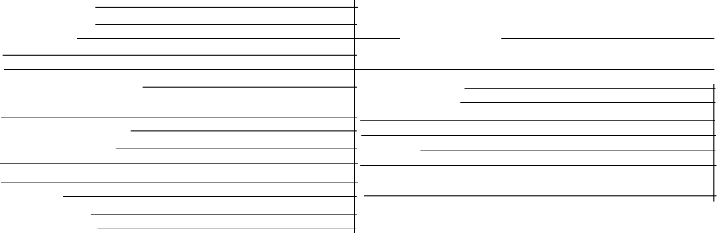
BridgeRoadway,ft (53):"9999" DesignatedNationalTruck NetworkCode(110):1
-On NationalTruck .
FutureAverageDaily Traffic(114):19,500
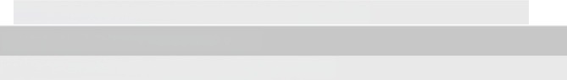
Year of Future AverageDaily Traffic(115):2034
MPO,Political Districts,and Cities
MetropolitaPlanningOrganization(MPO):
ode(111):1 Notrequired
U.S.CongressionalDistrict:
State Senate District:
State House District:
Code-
ate(90):July City(InfoBridgePlace Name):
DesignatedlnspectionFrequency(91):24
Fracture CriticalDetails(92A):N Notneeded Underwaternsp ection(92B):Y60
OtherSpecial Inspection(92C):N
Fracture CriticalDetailDate(93A):
Underwaternspection Date(93B):April2014
OtherSpecial InspectionDate(93C):

